Game Design Document



Naomi Mendoza
Shane Duffney
Angelica Cuadrado Rodriguez
Alfonso Raziel Mendoza Avila

Studio9 - AlfShaAngNao

03 - April - 2026
Directory

Executive Summary 2
Game Overview 2
Target Audience 3
Objective 3
Two-Player Local Competition 3
Map Design 3
Obstacles 4
Controls 4
Game Elements 4
User Interface (UI) 4
Gameplay UI 4
Main Menu UI 4
Game over screen 5
Assets 5
Visual 5
Audio 5

Executive Summary
What the Fish?! is a single-player, 3D educational arcade sorting game based directly on the real-world sport fishing advisories of the Kalamazoo River. The player acts as a Hero Inspector traveling down one continuous river map, rapidly sorting a massive surge of fish. Players must separate safe, nutritional fish from those heavily contaminated with Polychlorinated Biphenyls (PCBs) and mercury. The tone is fast-paced and lighthearted, but strictly grounded in actual Michigan "Eat Safe Fish" guidelines, concluding each session with a health recap that shows the direct consequences of the player's sorting decisions.

Game Overview
Genre: Educational PvE 3D Arcade / Sorting Game.
Pillars: Accessible • High-Speed Chaos • Real-World Education • Environmental Awareness.
- Fixed 3D perspective focusing on the continuously flowing Kalamazoo River.
- Rapid-fire inspection mechanics utilizing a strict, short UI timer to test player memory of real-world fish toxicity.
- Real-time background simulation: the river does not pause during UI inspection; missed fish despawn and waste valuable time.
- Resource management economy: balancing a "Food Quota" to prevent starvation against a "Safe Toxicity Threshold" to prevent citizen illness.

Target Audience

- Ages 10–35; casual to mid-core players who enjoy pick-up-and-play chaos.
- Fans of fast-paced puzzle, sorting, or management games.
- Players seeking short sessions with laughs, spectacle, and a light educational twist

Objective
Survive the level timer while accumulating enough food to meet the town's Food Quota.
Keep the accumulated toxicity (PCBs and Mercury) below the designated safety thresholds.
Review the end-of-session Health & Nutrition Recap to see the physical effects of your choices on the town's population.
Unlock the next, more polluted sector of the river by successfully feeding the town without causing a health crisis.
Gameplay Mechanics
- Engage the rapid flow of the river using a vertically moving hook.
- Trigger the Inspection UI upon hooking a fish, initiating a short, high-pressure decision timer.
- Recall stats from the Fishing Book to correctly choose "Keep" (Right) or "Throw Back" (Left).
- Manage the continuous background flow; if the UI timer runs out, the fish falls back into the water.
- The Mayor character appears dynamically on the UI, visually reacting in real-time (e.g., cheering, looking sickly) as the Food and Toxicity bars fluctuate based on your sorting accuracy.

Map Design
The game features one massive, contiguous 3D map representing the Kalamazoo River. The player progresses through three distinct difficulty sectors based on the real-world Michigan Department of Community Health advisory zones.
- Level 1: Battle Creek to Morrow Pond Dam (Advisory Area B)
  - Vibe: Light danger, natural, and relatively clean.
  - Gameplay: Introductory spawn rates. Most fish here are safe, with only specific bottom-feeders carrying dangerous toxins.
- Level 2: Allegan Dam to Lake Michigan (Advisory Area C)
  - Vibe: Half dangerous/half safe; moderate industrial presence on the riverbanks.
  - Gameplay: Faster water currents and mixed spawn rates. Players must exercise strict caution as more mid-tier contaminated fish appear.
- Level 3: Morrow Pond Dam to Allegan Dam (Advisory Area A)
  - Vibe: Fully red, highly dangerous. Visually polluted and heavily industrialized (historically designated as a Superfund site).
  - Gameplay: Maximum water speed and chaotic spawn rates. Almost all fish here carry severe PCB and mercury warnings, requiring split-second precision to find the rare safe catches.

Special Terrain Elements
- Water Currents: Speed up the movement of the fish across the screen based on the level, reducing the window the player has to hook them before they despawn.
- Pollution Gradients: As the player moves from Level 1 to Level 3, the water visually shifts from clear blue to a murky, hazardous hue, visually communicating the invisible PCB/Mercury threat.

Optional Item System (if time allows)
The Fishing Book: A toggleable glossary where players can pause the gameplay briefly to study fish types, visual identifiers, and their exact food/toxicity stats derived from the "Eat Safe Fish" guide.

Controls
Action | Keyboard + Mouse | Controller
Move Hook Up | W / Up Arrow | Left Stick (Up)
Move Hook Down | S / Down Arrow | Left Stick (Down)
Keep Fish | Right Arrow / D / Right UI Click | RT / R2
Throw Back Fish | Left Arrow / A / Left UI Click | LT / L2
Open Fishing Book | Tab | Y / Triangle
Pause | Esc | Menu

Game Elements
Core Interactions: The Fish Roster
The game features 6 specific fish species native to the Kalamazoo River. Four are drawn directly from the Advisory Map, and two are supplemental safe species.
- Safe / Good Fish:
  - Bluegill (Supplemental): A highly common panfish. Very low toxins; provides reliable, safe food for the quota.
  - Yellow Perch (Supplemental): A popular sport fish. Yields high food value with minimal mercury risk.
  - Smallmouth Bass (From Advisory): Safe for unlimited consumption in Level 1, but requires strict caution (limited servings) in Levels 2 and 3.
- Dangerous / Toxic Fish:
4. Largemouth Bass (From Advisory): Carries high mercury levels. Dangerous to consume, especially in Level 3.
5. Catfish (From Advisory): A bottom-feeder heavily contaminated with PCBs and Mercury in the lower river sections.
6. Carp (From Advisory): The ultimate hazard. Highly contaminated with PCBs; categorized as "Do Not Eat" across all areas of the river map. Catching and keeping Carp causes massive spikes to the toxicity bar.
Player Feedback
- Visual Reactions: The Mayor’s UI portrait updates dynamically. If the toxicity bar rises, he turns green and looks ill.
- Audio Warnings: A Geiger-counter-style clicking or alarm triggers when the player's toxicity bar approaches the failure threshold.

User Interface (UI)

UI State Management & The Fish Almanac
Play Screen
HUD Elements:
- Level Timer
- Food Quota Bar (Green)
- Safe Toxicity Threshold Bar (Orange/Red)
- Dynamic Mayor Portrait (Reacts to the current ratio of Food vs. Toxins).
To ensure the game maintains its high-pressure arcade feel, the UI operates under three strict visibility states:
- Default River State (Idle): The main Play Screen HUD is visible (Meters, Timer, Mayor, Population). The player is moving the hook, and the Fish Almanac button is active and clickable.
- Almanac Open State: When the player opens the Fish Almanac, the entire Play Screen (the river, the HUD, and the Mayor) is completely hidden. The screen is 100% dedicated to the Book UI, allowing the player to study without background distractions.
- Active Fishing State (Inspection): The moment the hook touches a fish, the Inspection UI pops up with the short decision timer. During this high-pressure state, the Fish Almanac is locked and unavailable. The player must rely purely on their memory to Keep or Throw the fish.
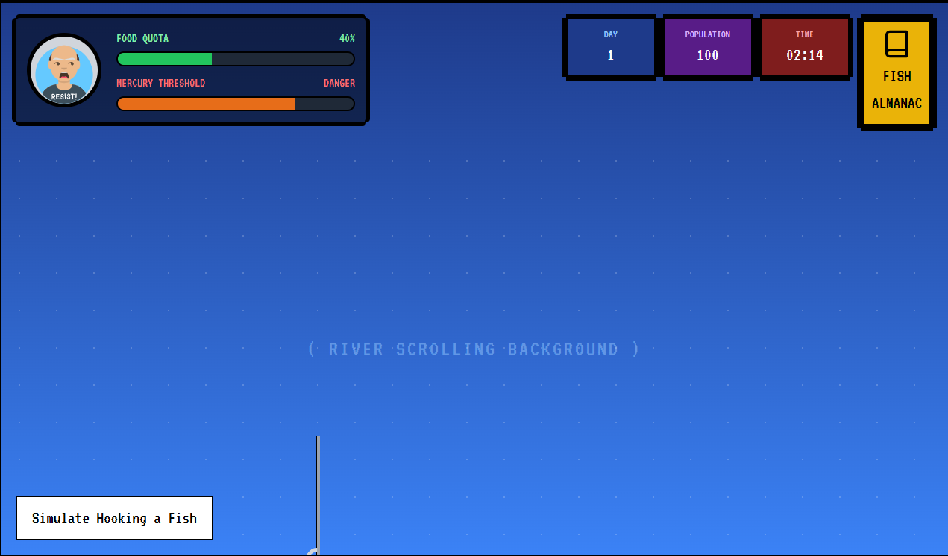
Main Menu UI
- Start Game
- Settings / Options
- Quit
Pause Menu
- Resume
- Fishing Book (Glossary)
- Restart Level
- Quit to Menu
Game Over Screen (Health & Nutrition Recap) Instead of a quiz, the end screen provides a data-driven breakdown of the session:
- Total Food Gathered vs. Quota Needed.
- Contaminants Ingested (PCBs / Mercury).
- Town Health Status: A direct translation of the player's performance based on the real Eat Safe Fish Guide (e.g., "Success: The town is full and healthy!" or "Warning: High PCB levels have caused a localized health crisis.").
- Options: Continue down the river, Retry Level, or Return to Menu.

Assets
Visual Style
- Bright, stylized 3D aesthetic to balance the serious educational theme.
- The fish models feature highly readable silhouettes and distinct colour patterns, so players can quickly differentiate a safe Bluegill from a toxic Carp during the short UI timer.
- The Mayor features exaggerated, cartoonish reactions in the HUD.
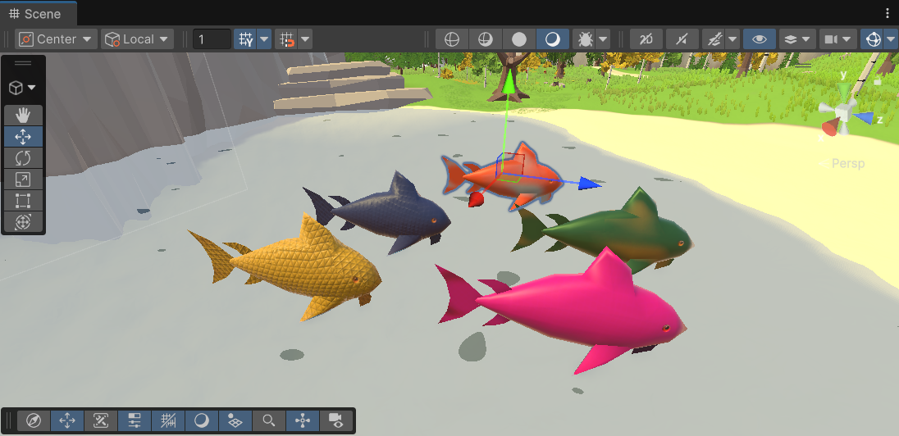
Level Design
One continuous, scrolling riverbank environment.
- Level 1 (Battle Creek): Lush green trees, clear water, bright lighting.
- Level 2 (Allegan): Bridges, moderate industrial pipes, slightly murky water.
- Level 3 (Superfund Zone): Warning signs, heavy industrial runoff pipes, and discoloured red/brown water effects to signify extreme danger.
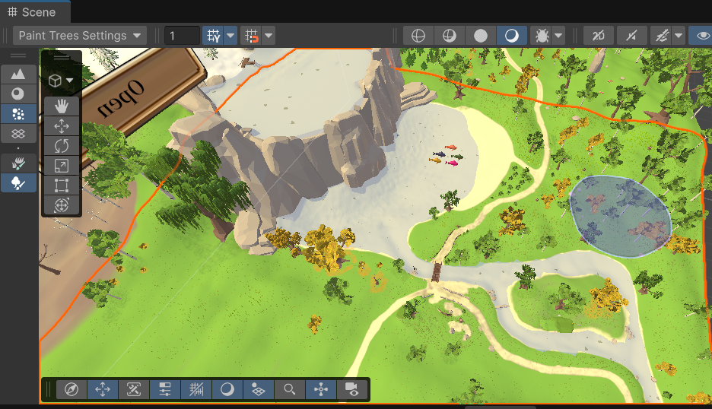
Audio Direction
- Music: Upbeat, chaotic arcade music that distorts or slows down slightly as the toxicity bar reaches critical levels.
- SFX: Splash sounds for hooking fish, a heavy "thud" for catching a massive Carp, and varied UI chimes for Keep/Throw decisions.

Testing & QA Plan
- Unit tests for fish spawning arrays ensuring the correct ratio of safe vs. dangerous fish appears in their respective river sections.
- Playtests focusing on the visual readability of the 6 fish species during the high-pressure UI inspection phase.
- Balance testing on the Health & Nutrition Recap to ensure the penalty for keeping a Carp feels appropriately severe compared to a Largemouth Bass.

